Hello everyone,
I'm going to take up a little more of your time, but I know that, like me, you are interested in these topics.
1 > I finally managed to replace the CD4046 with an ATtiny85 microcontroller.
Initially, I reason using digital sources (that of the NBTV club and my own)
I managed to do this thanks to the latest information I received from you, and I must say, Chris had sent me part of it.
I initially started with an ATtiny85 powered directly at 5V relative to ground. At first, it didn't work, or rather, it didn't work well.
I decided to decrease the damping resistance, which was 100K, and I got good results by reducing it from 100K to 22K.
However, my image was slowly oscillating from right to left.
On the oscilloscope, the signal from the ATtiny85 output to the motor control gate PB1 showed a DC voltage quite close to 5V (voltage feedback on capacitor C1) via the 22K resistor (PB1 in high impedance) and small pulses up to 5V whose duration oscillated with the image displacement oscillation).
So I decided to take up the idea from the NBTV club, which raised the pulse level by inserting an LED between the anode of the Zener diode and GND. The club used this trick to power its infrared disc sync LED. However, I used an LED because I already have an existing circuit for my infrared LED.
As a result, it works very well and this time my continuous component in return on PB1 is weaker and therefore the pulses have a greater height I lose this unwanted ripple and RV1 mainly has a role of shifting, of recentering the image.
Here is my diagram (it is also attached), you will notice the voltage dividers on TP2 and TP10 in order to bring the pulses into the input of the ATtiny85 to the correct level.

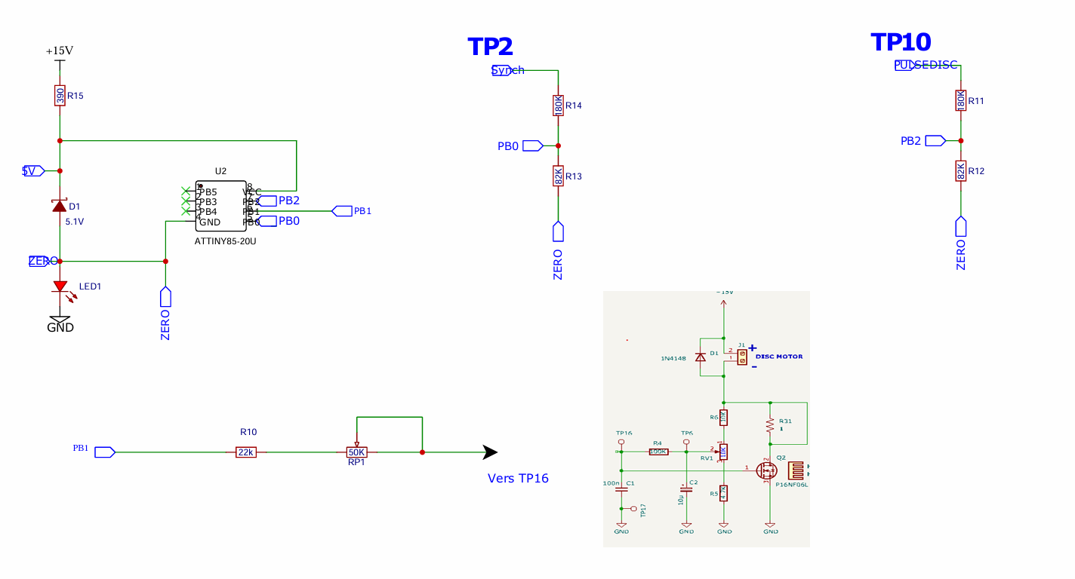
These voltage dividers were calculated before the LED was added; a little optimization would be needed for a final assembly, but for now it works.
The voltage across the LED is 2.10V.

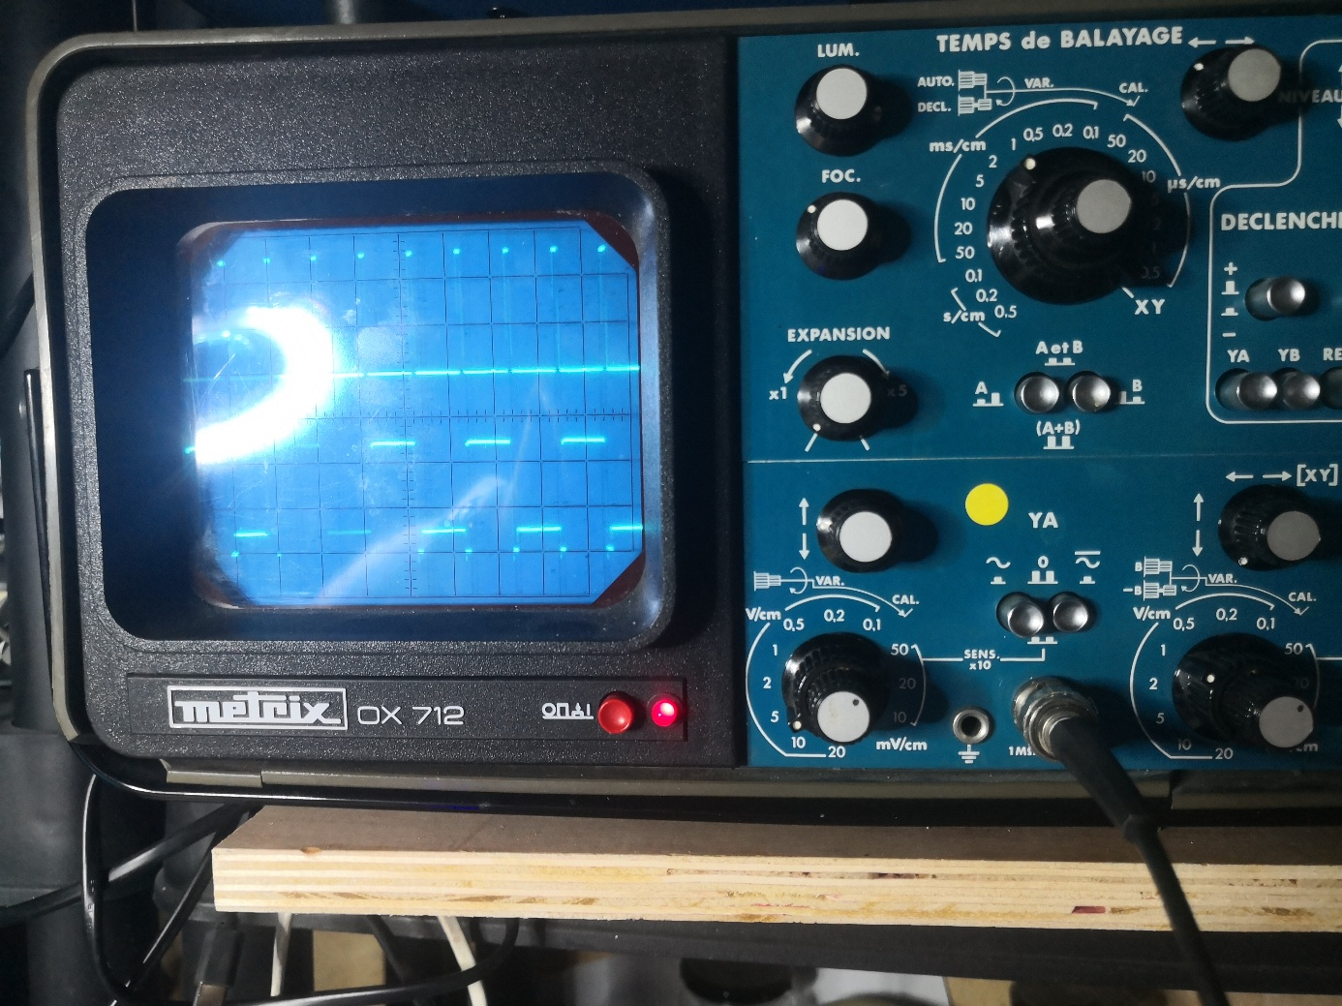
On the test pattern at the top, the sync pulses for channel A are 15V (5V 3 squares) on TP2 (white/black). At the bottom, the video signal for channel B is 1V 2.5 squares on TP1. The sync pulse is approximately 0.35V.
Synchronization after startup takes approximately 20 seconds and then there are no further dropouts.
This oscillogram is made from my personal target (see video DFTA206 https://www.youtube.com/watch?v=UIijKOTe098&t=26s ).

Using the black test pattern from the club's "PIC-BASED NBTV SIGNAL GENERATOR," I get the same results and observe that the sync points are very sharp; I don't lose sync when changing frames (by using SELECT TEST SIGNAL) . However, if I make slight variations in level, I can experience brief, minor signal drops.
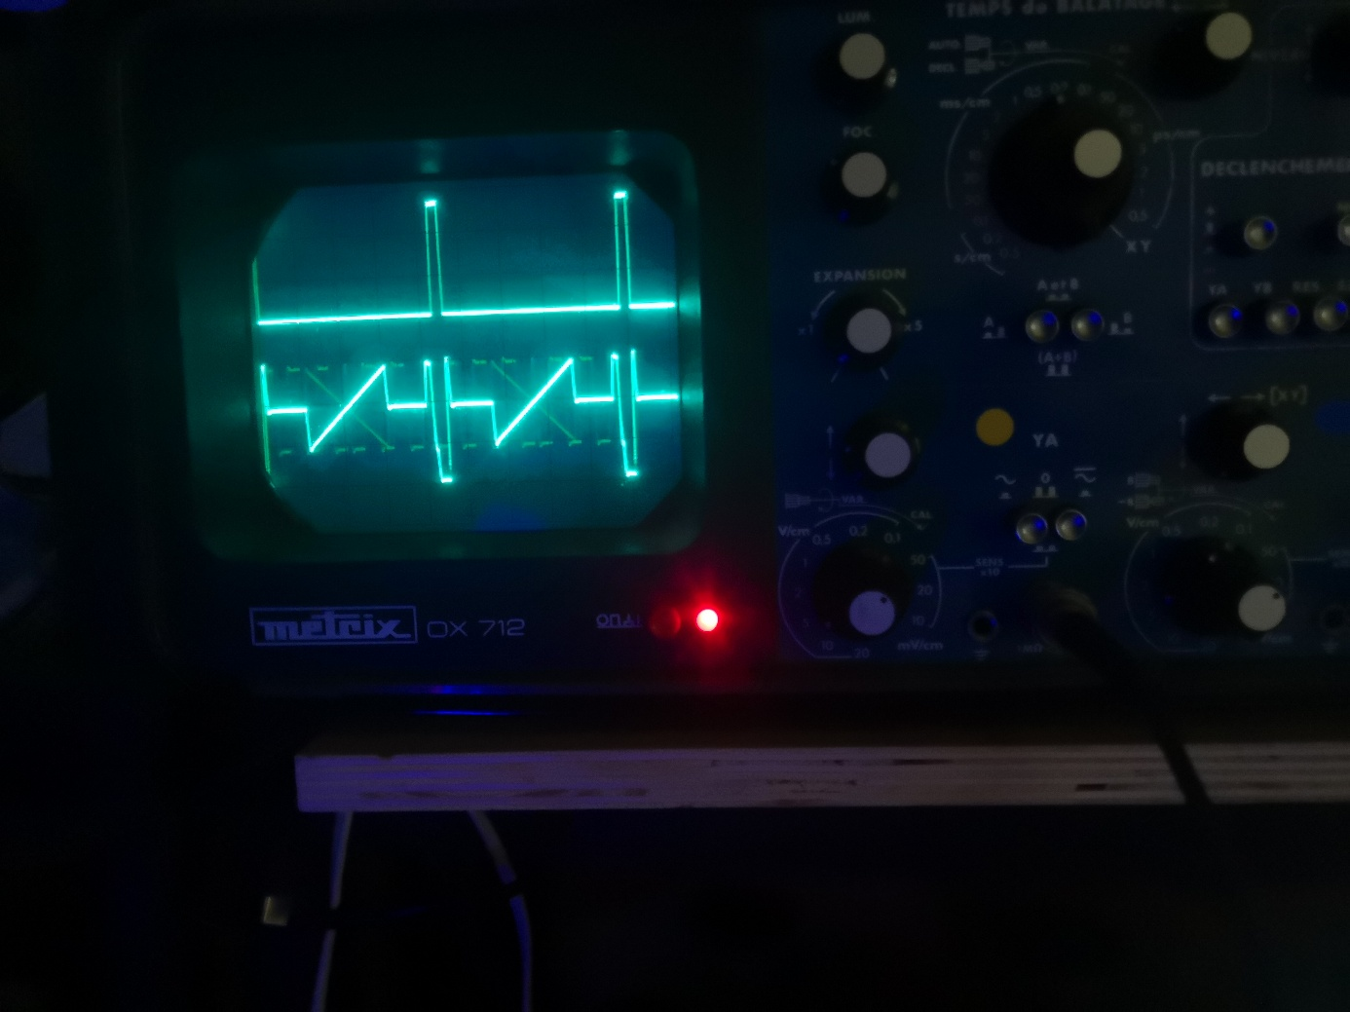

Let's now move on to the recorded analog targets; I'll start with the club's targets.
I transmit them using a small HUAWEI laptop and a 3.5mm jack/jack cable
I set the same level as on the test pattern in the 2nd ^{photo} , no problem, the sync well is perfect (track10).
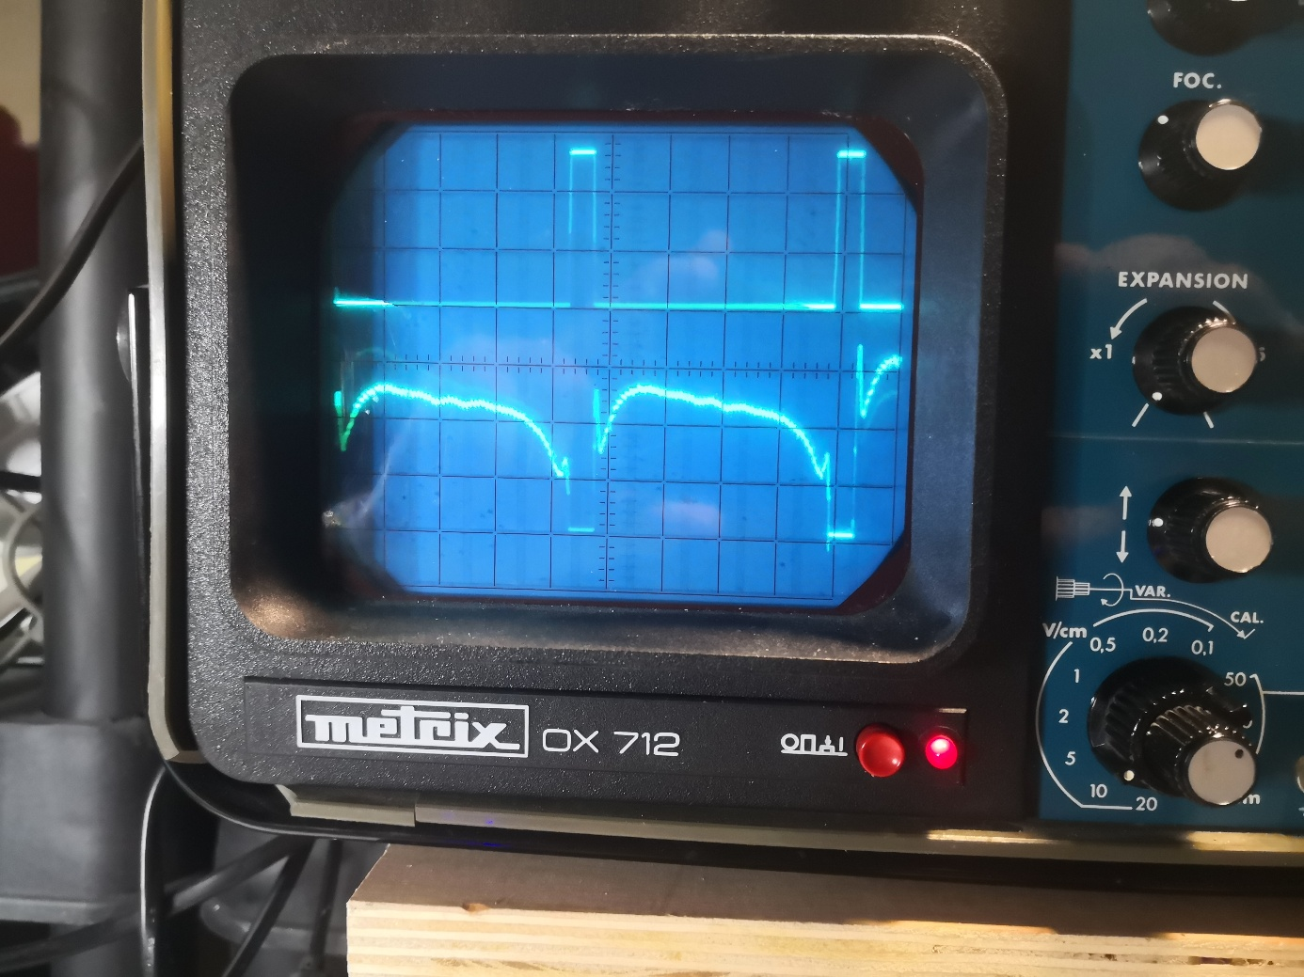

Track 11, 4th ^{photo} : it doesn't work, but that's normal; the video signal drops as low as the bottom of the sync well. Same for track 15.
Unfortunately, it's not very visible in the photo, but I guarantee that on some lines the black level of the video is as low as the bottom of the sync well.
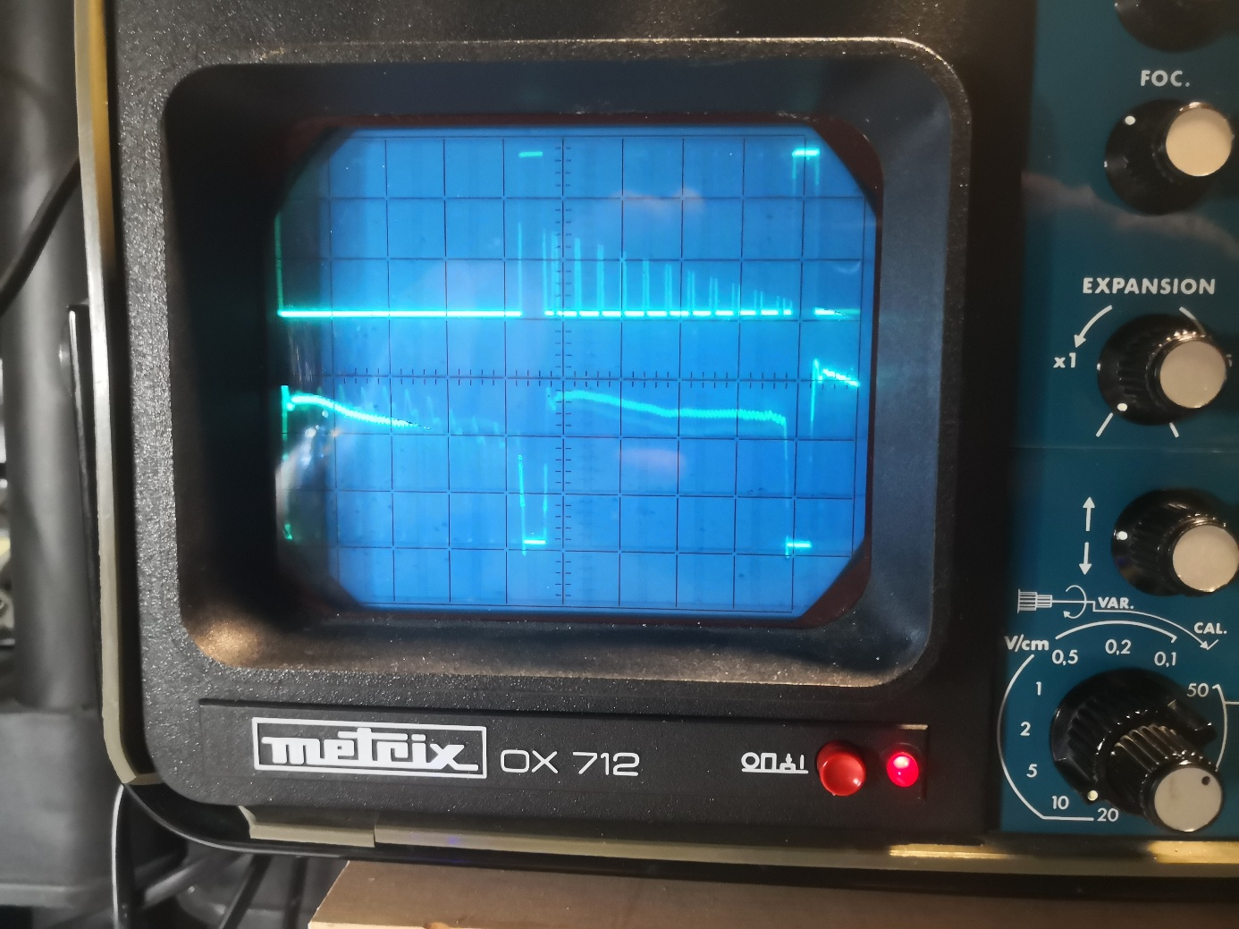

And for 02Raymond it doesn't work even though it sometimes happens but sometimes doesn't, but in this case we see that the low level of black also goes very low.
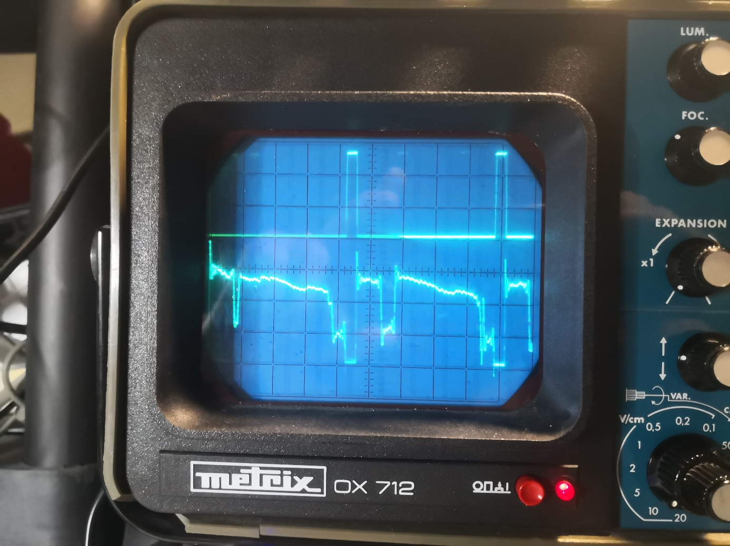
I am attaching these files (note that Raymond is reversed compared to your files).
The Raymond cartoon was created using the Video2NBTV program.

This is where I'm at, and all of this makes me think that I'm not really working with the right files.
For now I am using a small HUAWEI PC as my source, I have no certainty that it is suitable, of course.
I had also found a small stereo player that seemed promising, but…

